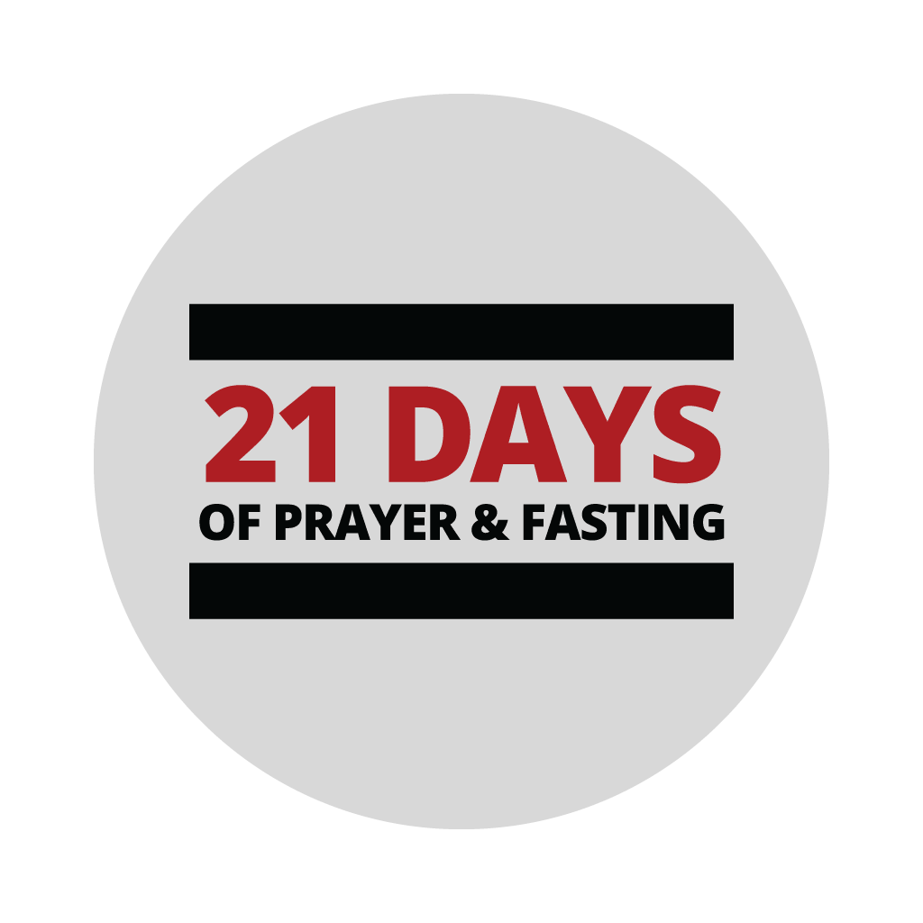
First Memorial Baptist Church

January 11– 31, 2022
Daily Prayer Points:
- Thank God for everything He’s done for you and FMBC (provision, protection, health etc.) (Ps 100:4; 1 Thess. 5:18; Ps 103:1-14)
- Pray for forgiveness and cleansing from sin (2 Chr 7:14; Ps 24:3-4; 1 John 1:7-10)
- Pray that God’s will be done, and His kingdom will come upon our lives, church, communities, and nation (Matt 6:10,33)
- Pray for an outpour of God’s goodness, mercy, and compassion (Exodus 33:19; Rom 9:15,18; Jer 31:20; Deut 13:17; Lk 18:38)
- Ask God to empower and fill you with His Holy Spirit (Acts 1:8; 1 Corinthians 4:20; Luke 10:19; Ephesians 3:20)
- Ask God to open your eyes to His vision and plans for FMBC and your life (1 Corinthians 2:9, Habakkuk 2:1-2)
- Pray for a great spiritual awakening/revival-For the salvation of those that do not know Jesus (Matthew 6:10, Acts 14:27; 2:2,5-8,41; 1 Corinthians 16:9)
- Pray against (rebuke) every wind/storm that is blowing against you and FMBC… (Mark 4:37; Number 11:31; Jonah 1:4)
- Declare/pray peace and blessing over specific areas of your life – health, relationships, marriages, finances etc. (Mark 4:38-39; Job 22:28-30; Luke 17:6; Mark 11:23)
Additional specific prayer points each day:
MONDAY
Pray for the fulfillment of God’s great plans for your life and FMBC (Genesis 1:26-28; Psalm 8:4-5; Psalm 3:3; Ezekiel 13:18)

TUESDAY
Pray that God would give you and FMBC unprecedented breakthrough-be specific about areas where you desire breakthrough…Especially, concerning the pandemic, health and relationships (Isaiah 43:19, John 10:10; Romans 11:29; Psalm 91)

WEDNESDAY
Ask the Lord to provide every resource needed to fulfill your destiny and FMBC’s (Psalm 23:1; Luke 9:2-4; Haggai 2:8; Psalm 50:10; Luke 12:32)

THURSDAY
Pray for revelation of specific strategies/keys needed for breakthrough in this season of life (1 Corinthians 2:9, Genesis 22:11-13; Exodus 14:15-16; Exodus 7:1; Proverbs 16:9; Exodus 12:35-36)

FRIDAY
Ask God to bless FMBC, and make us a source of blessing (Acts 20:35; Genesis 12:2)

SATURDAY
Pray against every contrary power that is at work against you and FMBC, and against God’s plan for our lives (Isaiah 54:17;1 Peter 5:8; Luke 10:19; 2 Corinthians 10:4; Matthew 18:18; Psalm 68:1-2)

SUNDAY
Ask God for discernment of what God is doing in this season of your life, and what we should be doing (Isaiah 60:4; 1 Chronicles 12:32)

